Polynomial Regression
Code:
import pandas as pd
import numpy as np
import matplotlib.pyplot as plt
import seaborn as sns
from sklearn.model_selection import train_test_split
from sklearn.preprocessing import StandardScaler, OneHotEncoder, PolynomialFeatures
from sklearn.compose import ColumnTransformer
from sklearn.pipeline import Pipeline
from sklearn.impute import SimpleImputer
from sklearn.linear_model import Ridge
from sklearn.metrics import r2_score, mean_squared_error, mean_absolute_error

load = pd.read_csv("/content/manufacturing.csv")

display(load.head())
print("\nShape of dataset:", load.shape)
print("\nDataset Information:")
load.info()
print(load.isnull().sum()

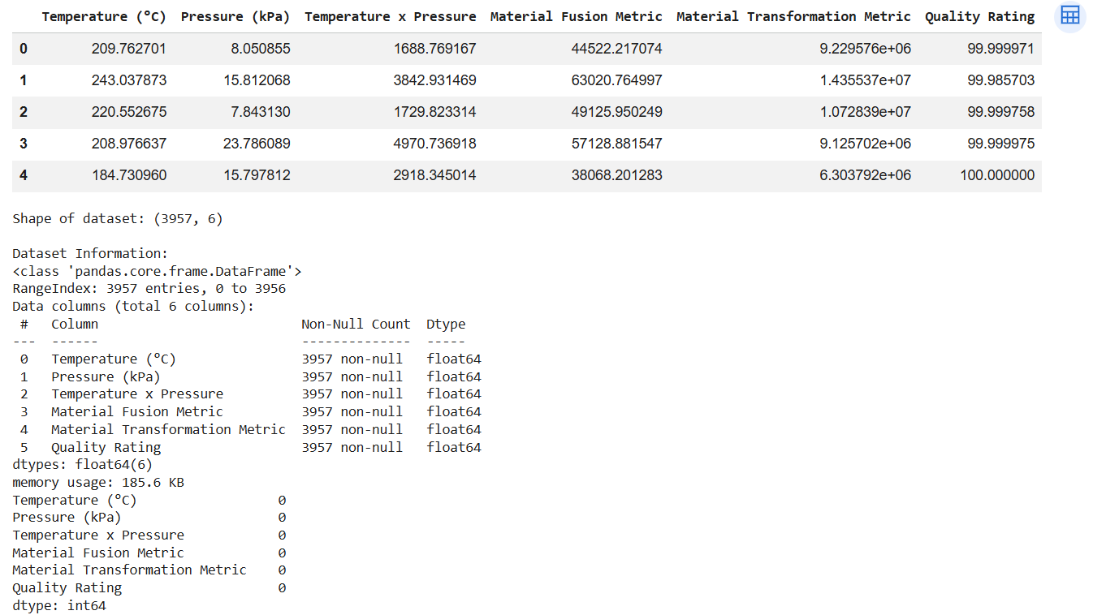

X = load.drop('Quality Rating', axis=1)
y = load['Quality Rating']

X_train, X_test, y_train, y_test = train_test_split(X, y, test_size=0.2, random_state=42)

num_cols = X.select_dtypes(include=['int64', 'float64']).columns.tolist()

num_transformer = Pipeline(steps=[
('imputer', SimpleImputer(strategy='mean')),
('scaler', StandardScaler())
])

preprocessor = ColumnTransformer(
transformers=[
('num', num_transformer, num_cols)
])

poly_model = Pipeline(steps=[
('preprocessor', preprocessor),
('poly', PolynomialFeatures(degree=2, include_bias=False)),
('model', Ridge(alpha=100.0))
])

poly_model.fit(X_train, y_train)
y_pred = poly_model.predict(X_test)
print(f"R² Score: {r2_score(y_test, y_pred):.4f}")
print(f"RMSE: {np.sqrt(mean_squared_error(y_test, y_pred)):.2f}")
print(f"MAE: {mean_absolute_error(y_test, y_pred):.2f}")
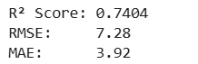

fig, ax = plt.subplots(figsize=(14, 5))

ax.scatter(y_test, y_pred, alpha=0.3, color='teal', label='Predicted')
ax.plot([y_test.min(), y_test.max()], [y_test.min(), y_test.max()], 'r-', lw=3, label='Perfect Fit')
ax.set_title('Actual vs Predicted Salary')
ax.set_xlabel('Actual Salary')
ax.set_ylabel('Predicted Salary')
ax.legend()
plt.tight_layout()
plt.show()

Output:
